Delaware Department of Transportation
PUBLIC NOTICE

Nicole Majeski Secretary
VIRTUAL PUBLIC HEARING
For the Abandonment & Vacation of the Improved Portion of Old Capital Trail
Newark, New Castle County, Delaware
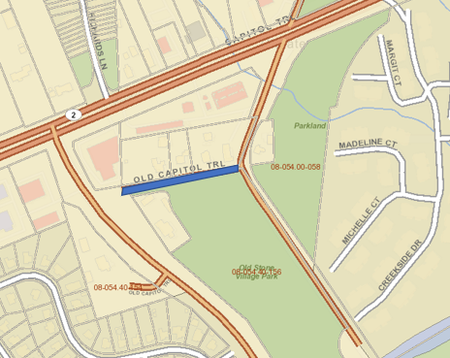

Tuesday, November 7, 2023 Promptly at 5:00 PM
WHEREAS, The Delaware Department of Transportation, (DelDOT) has maintenance control of the improved roadway of Old Capital Trail, Newark, New Castle County, Delaware; and

WHEREAS, an adjoining property owner, has petitioned DelDOT to consider the vacation and abandonment of the public roadway of an improved portion of Old Capital Trail, measuring approx. 15 linear feet in width by 461 feet in length, and located South of Robert W. Kirkwood Highway (Rt. 2) and West of Old Harmony Road. The existing alignment will cease to be of necessity to the highway system.

WHEREAS, Title 17, Section 1311 of the Delaware Code grants DelDOT the authority to vacate and abandon public roads and right-of-way or parts thereof, ceasing to be of necessity to the general highway system.

NOW, THEREFORE, BE IT RESOLVED by DelDOT that a Virtual Public Hearing shall be held with regard to the proposed vacation and abandonment of a portion of the improved Old Capital Trail. The hearing will be held online via the WebEx platform on Tuesday, November 7, 2023.
To join this online event
1.Go to https://stateofdelaware.webex.com/stateofdelaware/j.php?MTID=md35add0ce1e33c79f753a80b21907ccb
You may click the “Join by Browser” link to avoid downloading application.
OR Join by Meeting Access Code: 2357 586 8254
2. Enter the event password: DelDOTHearing
3. Click "Join Now".
4. Follow the instructions that appear on your screen to join the teleconference.
OR you may call and join from a mobile device using 1 (408) 418-9388 and enter the meeting access code above.
Public comments concerning this matter will be received PROMPTLY at 5:00 PM.

DEPARTMENT OF TRANSPORTATION
Nicole Majeski, Secretary
Shanté Hastings, Deputy Secretary / Chief Engineer
For additional information contact Laura Peretiatko, DelDOT Land Services Right of Way Agent: 302-760-2223.

